Answer all the questions.

1. Consider the following variables’ declarations.

int a = 5674;

int b = 066666;

int c = 0xcdef2;

Predict the output resulting from each of the following printf()statements.

|  |  |  |  |
| --- | --- | --- | --- |
| (a) | printf("%d\n",a); | (b) | printf("%+d\n",a); |
| (c) | printf("%.6d\n",a); | (d) | printf("%06d\n",a); |
| (e) | printf("%+06d\n",a); | (f) | printf(" %d\n",c); |
| (g) | printf("%x\n",c); | (h) | printf("%#0d\n",b); |
| (i) | printf("%#X\n",c); | (j) | printf(" % d \n",a); |
| (k) | printf(" %-#6x\n",a); | (l) | printf("%#X\n",a); |

1. Refer to the following declaration:

double i=5.678;

What will be printed by each of the following printf() statements?

|  |  |  |  |
| --- | --- | --- | --- |
| (a) | printf("%f\n",i); | (b) | printf("%+f\n",i); |
| (c) | printf("%+f\n",i); | (d) | printf("%.2f\n",i); |
| (e) | printf("%09f\n",i); | (f) | printf("%+09f\n",i); |
| (g) | printf("%10.3f\n",i); | (h) | printf("%e\n",i); |
| (i) | printf("%10.2E\n",i); |  |  |

1. Consider the following variable declarations:

int part1; float part2;

Write the appropriate printf() statements to print

* 1. The value of part1, left aligned in a field width of 10.
  2. The value of part1, left aligned in a field width of 10, with a plus sign if the value is positive.
  3. The value of part2, left aligned in a field of width 15 in floating-point notation.
  4. The value of part2, left aligned in a field of width 15 in exponential notation.
  5. The value of part2, left aligned in a field of width 15 in floating-point notation with 3 digits of precision.

1. Write the scanf() statements for the following variables declaration:

int c1; char c2; double c3;

float c4;

1. a) Write the getchar() and putchar() statements for the following variables declaration:

char letter, chr;

b) Write the output for the program below when the input is PASUM:

#include <stdio.h>

int main()

{

int i;

char ch;

for(i = 0; i < 5; i++)

{

printf("\nEnter a single character >> ");

ch = getchar();

putchar(ch);

getchar();

}

return 0;

}

1. Write a program which prints a report that has the following format. Use reading and displaying strings **ONLY** with **gets( )** and **puts( )** functions.

7) Write a program which print the output as below

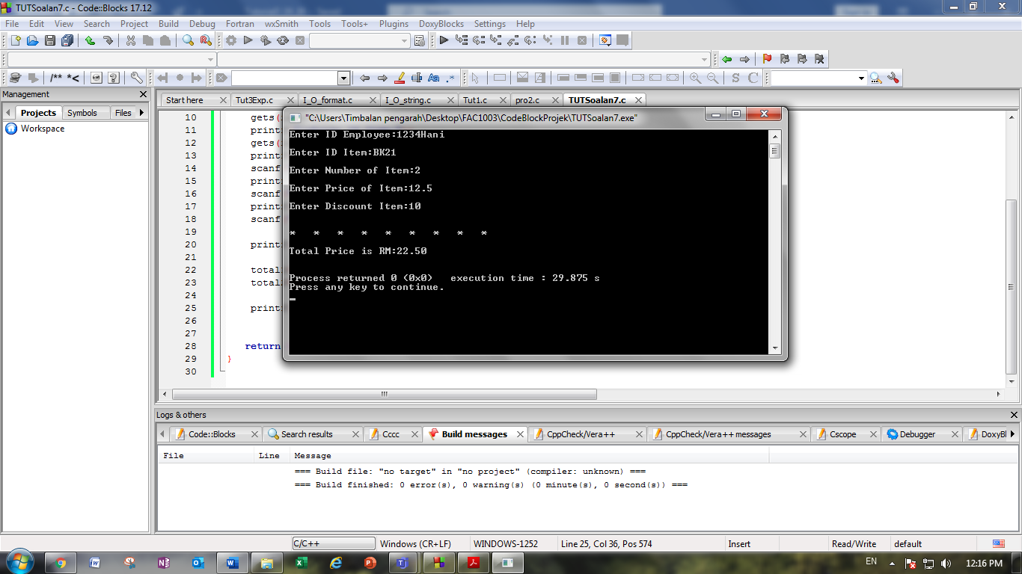

8) Write a program to calculate annual savings based on the flowchart given below



